# **Development**

## What Features Are Being Developed?

* Inputs for each user to input their name
* The gameboard being created as a list
* Inputs for what number of the grid the user wants to play
* If statements used to see if the number has already been played
* If statements used to see if the player has won or the game is a tie

## Show Annotated Code

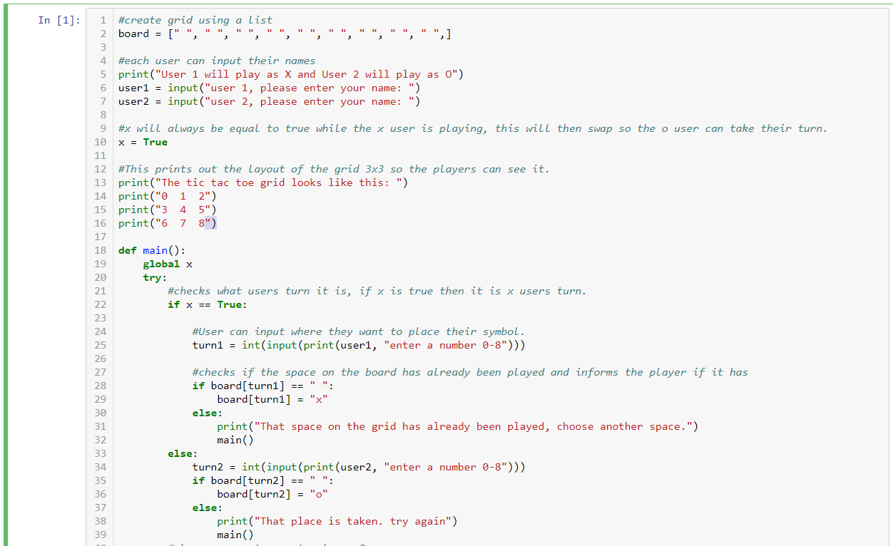

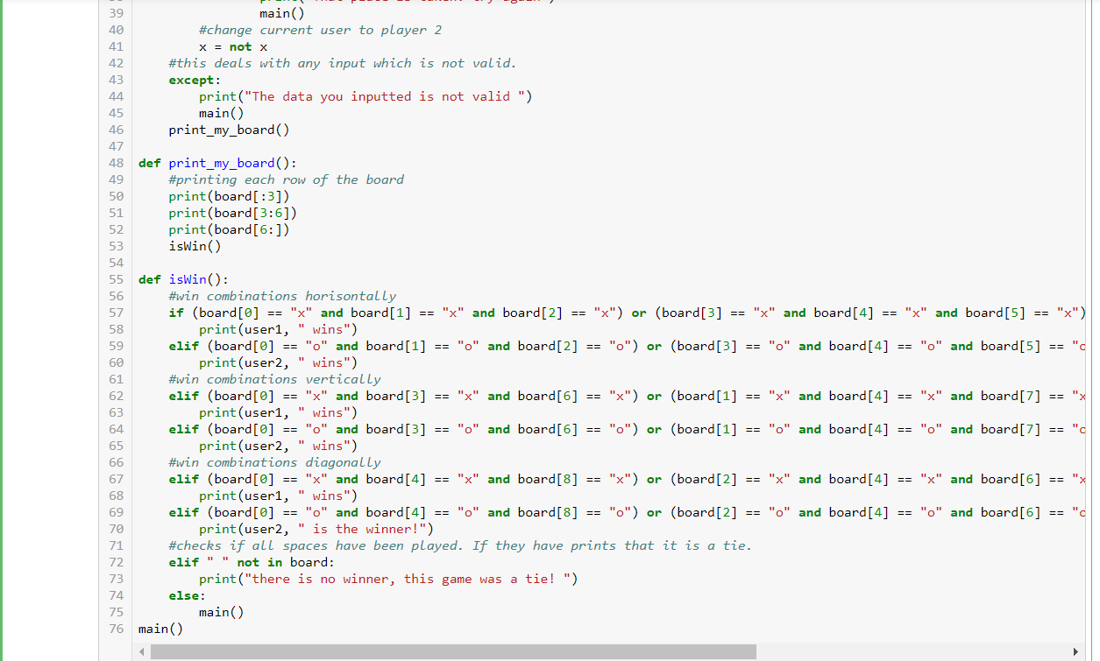

## Show Testing For Functionality And Debugging

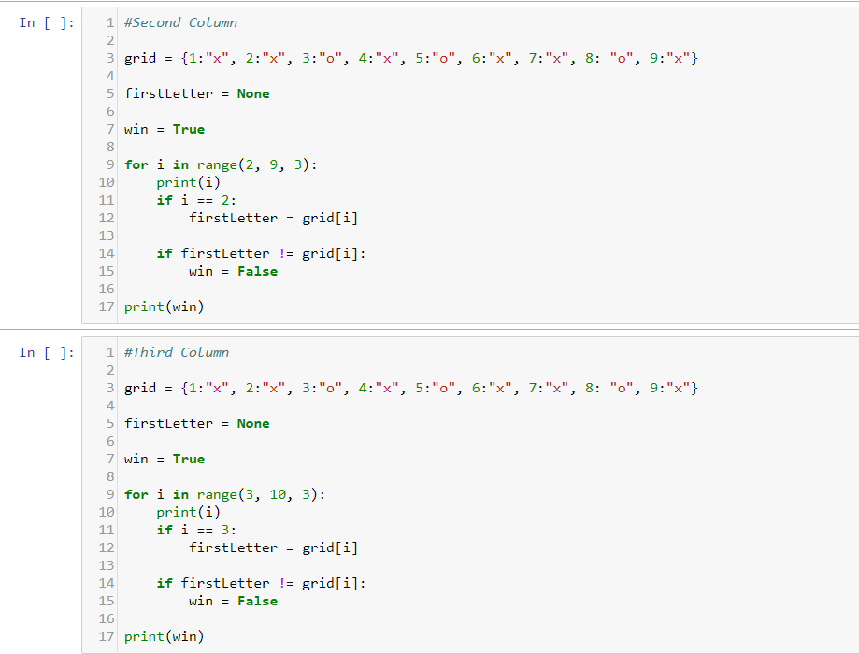

This code had been so each cell would check for a different win. The two cells shown above check wins for the second and third columns. The problem with this code was that the dictionary was already inputted, when to play the game a user would have to input into the dictionary.

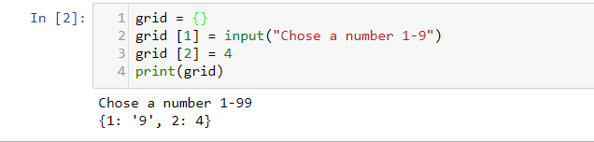

To fix this, I worked out how to create dictionaries using input. Here i stated the key and then allowed the user to input the value for each key. Again this was a problem as it would not allow users to choose anywhere on the 3x3 grid.



After trying to work with a dictionary i decided to use a list as i thought this would be an easier option. I created the grid using a list.